Planes, Trains, and Automobiles: Modeling Rail Transit’s Effect on
Emissions, Safety, and Travel Time
- Introduction
1.1 Motivation
The United States is one of the largest countries in the world, yet one of the last developed countries to implement a robust rail transit system, much less high-speed rail (HSR) system. Neither a lack of demand or “rail-worthy” corridors can be cited as the reason for this. Indeed, in 2025 there have been at least 80,000 passengers flying each month from the DFW area to Houston, and likely even more driving between the two areas (“Air Carriers : T-100 Domestic Segment (U.S. Carriers)”). In other words, there are hundreds of thousands traveling along this roughly 250-mile corridor, which lies within the “goldilocks zone” for high-speed rail of about 100-500 miles (“Breakeven Distances”). In corridors like this one rail, particularly HSR, may provide a competitive alternative. In this paper, we seek to quantitatively assess how rail transit performs compared to air and road transit in three key areas. Next, we provide the source and other information regarding our data.
1.2 The Data
Our data necessarily had to come from a country other than the US, and in choosing a source for our data, we sought two criteria: high-quality data and public accessibility. The European Union (EU) provides reliable datasets for several measures of interest through its statistical office, Eurostat. Through Eurostat, we sourced datasets for three variables, which we treat as our response variables: emissions by mode (i.e., air, rail, and road), safety by mode and travel time by mode. These variables are measured annually. Eurostat allows users to “customize” datasets by including or excluding certain member countries, adjusting time ranges, and other modifications. For our purposes, we selected all available countries for each dataset and all available time points. Unfortunately, our data is unbalanced as not every country reports data for every variable each year, but this did not undermine our ability to fit models as will later be seen. In general, most countries have data for these variables starting in the 1990s. This is a high-level description of our response variables, and each variable will be more particularly described at the beginning of its respective section.
Given the limited time range of our data, we could not treat our data as a time series. As such, we added other readily available variables to our panel data. We intended to bolster our data with the addition of these variables, which could serve as predictors. These variables included GDP per capita, area, climate risk index (CRI) score, and others. The World Bank’s DataBank contains data on “World Development Indicators” and served as our source for the predictor variables. How these predictors are specifically used is described in each section.
1.3 Aims
With these data, our aims were straightforward. We wanted to assess how rail transit performs relative to air and road transit with respect to our three response variables. Specifically, we sought to
1. Assess if there is a difference in emissions efficiency for each mode, find a way to model difference, and extrapolate these results to the US.
2. Examine if there is a significant difference in the safety of trains as opposed to road travel. More specifically, we would like to see if there is a difference in the number of fatalities by volume (passenger-kilometers) for rail versus road in countries.
3. Determine if there is a difference in total travel time between rail and flight travel across specific travel routes. Importantly, we will be looking at total travel time and not just time in transit to account for other time investments like time spent in airport security.
- Overview of Methods
Before exploring each variable, we briefly discuss our methods as we used similar methods in analyzing each variable.
2.1 Paired t-tests
Our data naturally lends itself to paired $t$-tests given that we are observing how one group (rail) compares to another (air and road). Of note, the tests we performed were not classical paired $t$-tests for emissions and safety, but the tests we ran were analogous. We computed
• One-sided $t$-test of the difference in normalized emissions between rail and air transit ($Air-Rail$), as well as rail and road transit ($Road-Rail$) for each year
• One-sided $t$-test testing if the ratio of Rail to Road accidents by volume ($Road / Rail$) is greater than 1. A ratio greater than 1 means rail is safer than road since there are more road accidents by volume. We do this for each year since each year cannot be considered independent.
• Two-sided paired $t$-test of the difference in total trip time between Rail and Flight for specific corridors ($Rail - Flight$). Two were done, one for the conventional rail and one for the high-speed rail.
2.2 Year-by-year linear models
Our initial attempt at modeling simply extended what we did with the $t$-tests; i.e. for each year, we fit linear models for each difference and ratio. At this point, we introduced our other variables as predictors. These models provided a baseline for our more conventional longitudinal data models.
2.3 Mixed effects models
Our final models were mixed effects models. With these models we introduced a fixed “Mode” effect, allowing us to move beyond modeling differences and ratios. The mixed nature of the models also enabled us to fit random effects, particularly random “Country” effects.
- Emissions
The emissions data from the EU are measured in metric tons emitted per year, and we observed carbon dioxide as this is the transportation sector’s largest source of greenhouse gases. We collected this total for the three modes. Now, some countries are vastly more populous than others (and thus emit more CO₂ than others due to size), so we needed some way of normalizing the data to fairly compare across countries. We normalized emissions by volume (passenger-kilometers, or PKM), which the EU reports each year for each mode. PKM is reported in millions of passenger-kilometers, so the normalized emissions are measured in g CO₂/PKM.
3.1 Exploratory Data Analysis
A natural starting point for our EDA is to consider how the modes compare by normalized emissions. We looked at three of the largest countries in the European Union: France, Germany, and Italy.
Fig. 3.1: Normalized Emissions by Mode
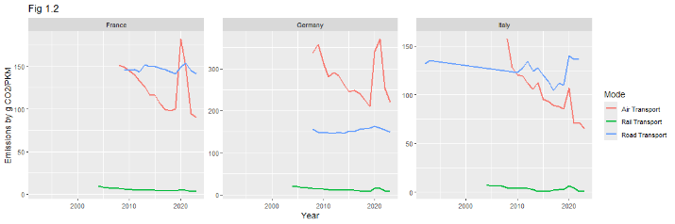
Even after accounting for volume, rail (green) is the most efficient transit mode in all three countries. Interestingly, road (blue) and air (red) emissions appear more comparable, particularly in France and Italy. In these two countries, air travel can be up to 1.5 times more efficient than road. In Germany, it seems air transportation is the least efficient transit mode. Not only is rail transit more efficient relative to air and road, but it also has been increasing in efficiency until recently.
Fig. 3.2: Increasing Rail Efficiency over Time
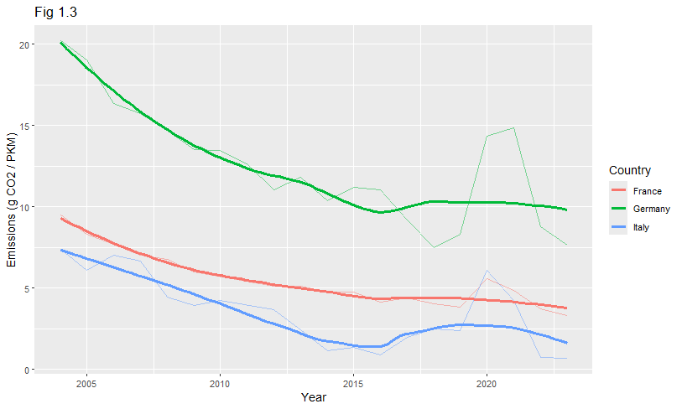
Displayed in the figure are the normalized rail emissions for the three countries with a curve fitted using the LOESS smoothing method. The smoothed curve clarifies that rail efficiency has increased about two-fold in each country since the early 2000s. This increase in efficiency has slowed in recent years, but if the US were to adopt rail transit as these countries have, the country would be implementing both an efficient and historically improving technology.
3.2 Initial Results
First, we review the results of tests of the two differences: $Road-Rail$ and $Air-Rail$. Again, we are interested in seeing if rail emits less emissions, so our alternative is that the difference is greater than 0.

Fig. 3.3: Results of $t$-tests for $Road-Rail$, selected years
Year | Mean Difference | $t$-statistic | $p$-value | $$n$$
2008 | 75.2 | 0.886 | 0.198 | 11
2009 | 162 | 1.56 | 0.0737 | 12
2010 | 161 | 1.58 | 0.0712 | 12
2013 | 99.6 | 1.9 | 0.0421 | 12
2017 | 89.5 | 1.53 | 0.0823 | 9
2020 | 140 | 14.3 | 0.00000365 | 7
2023 | 510 | 2.15 | 0.0341 | 8
In these selected years, $Road-Rail$ is significant (at $α=0.05)$ for three years, one of which is 2020, a year in which rail transit contracted due to the COVID-19, which explains its more extreme value relative to the other $p$-values. Interestingly, there are years with a greater mean difference but insignificant $p$-value. The reason for this is that Lithuania produced a large negative difference for most years (e.g., -770.38 in 2008). Of note, Lithuania’s rail volume is much lower relative to other more developed EU countries, indicating that economic development factors may help predict emissions efficiency (Appendix A.1).
Fig. 3.4: Results of t-tests for $Air-Rail$, selected years
Year | Mean Difference | $t$-statistic | $p$-value | $$n$$
2008 | 259 | 1.3 | 0.103 | 25
2009 | 61.9 | 1.22 | 0.118 | 24
2010 | 291 | 1.42 | 0.0842 | 24
2013 | 243 | 1.53 | 0.0703 | 24
2017 | 300 | 1.56 | 0.0671 | 23
2020 | 930 | 1.3 | 0.105 | 22
2023 | 336 | 1.75 | 0.0471 | 22
The $Air-Rail$ difference returns fewer significant years than $Road-Rail$. This is to be expected as following methods will demonstrate that, in general, air and rail are closer efficiency-wise than road and rail. Unlike $Road-Rail$, $Air-Rail$ is not significant for 2020, and this is likely because commercial air travel also contracted due to COVID-19. However, the mean $Air-Rail$ differences are generally greater than $Road-Rail$ but still not significant. These findings corroborate that factors associated with economic development help explain mode efficiency.
Next, we discuss our preliminary models: year-by-year linear models. With these models, we fit linear models to each year. For each year we fit two models, one for each difference. We start by using various predictors associated with economic development and efficiency, like GDP per capita, urbanization rate, and renewable energy percentage. Note that log-transformed GDP per capita, bringing it to a similar scale as the other two predictors. These first iteration of models returned high $p$-values for all three effects across the board. Thus, we eliminated one of the effects (renewable energy percentage) and fit two-factor models. These models, again, yielded insignificant effects, but for our fully simplified models we retained the predictor that consistently returned the lowest $p$-value, GDP per capita.
Fig. 3.5: Summary of single factor (GDP per capita) linear model for $Air- Rail$ for the year 2023
Coefficient estimate | Std. error | p-value
(Intercept) $β_{0}$= -736.0 | 215.6 | 0.00275
(GDP) $β_{1}$= 0.02982 | 0.005018 | 8.21$×$10⁻⁶
Above are the results from one of the more “favorable” years. For the sake of concision, we will not review the diagnostics as this is not our final model. The GDP effect is significant, but we note that its magnitude is less than 0.01 and is much smaller than the magnitude of the intercept. These results relate that as suspected, GDP does predict efficiency, but for these models, its effect is not optimally captured. One reason for this is that our response is the difference, and as we observed, the difference is not significant most years. Finding a way to include a Mode effect will allow us to capture emissions itself as a response, which is just one of the improvements we achieve in our optimal model.
3.3 Optimal Model and Extrapolation
Our final method, mixed effects modeling, yielded the most significant effects. We added a Mode effect, allowing us to predict emissions for each mode, as well as a random intercept per country. This random intercept allowed countries “baseline” emissions to modulate up and down relative to the fixed intercept.
At first, we included other predictor variables, including a new one: area, but again, a parsimonious model with just GDP per capita performed the best. Importantly, we log-transformed and then centered GDP around the mean (to address collinearity issues in preliminary mixed models). Also, we log-transformed emissions to stabilize its variance. Our final random intercept was
$\log{{\text{emiss}}_{ij}}=β_{0}+β_{1}I_{\text{Air}}+β_{2}I_{\text{Road}}+β_{3}{\text{gdp}}_{ij}+u_{j}+ϵ_{ij},$
where $i=$ observation (year), $j=$ country, and $u$ is the random intercept.
Fig. 3.6: Summary of fixed effects
Estimate Std. Error df t value Pr(>|t|)
(Intercept) 3.31707 0.17054 26.25711 19.450 < 2e-16
Air Transport 1.25992 0.07455 1151.89126 16.901 < 2e-16
Road Transport 2.03416 0.08729 1159.60178 23.303 < 2e-16
log(gdp_centered) -0.54903 0.18310 98.48988 -2.999 0.00343
All the fixed effects are significant, particularly the Mode effects, with rail transit being the reference mode. We see that given GDP, the model predicts air transit emits $e^{1.26}≈3.5$ times more CO₂ per PKM, and that road transit emits $e^{2.03}≈7.6$ times more CO₂ per PKM. We also see that a larger GDP means greater efficiency as per log-unit increase above average GDP per capita, the model predicts a country emits $e^{-0.55}≈0.58×$ as much CO₂ per PKM. Finally, the magnitudes of the correlations between the fixed effects are all less than 0.4 (Appendix A.2). The random effects return some interesting results: most countries have random intercept effects less than 1, but Iceland, Ireland, and the Netherlands have effects greater than 1.
Fig. 3.6: Variance of random effects
Groups Name Variance Std.Dev.
Country (Intercept) 0.7375 0.8588
Residual 1.1666 1.0801
The residual variance is larger than the variance due to country random intercept, with the latter accounting for about 39% of the total variance. This means most (61%) of the variability is due to within-country noise, so our model does lack some explanatory power in this respect.
Before extrapolating to the US, we go over the model’s diagnostics.
Fig 3.7: Emissions Mixed Model Diagnostics
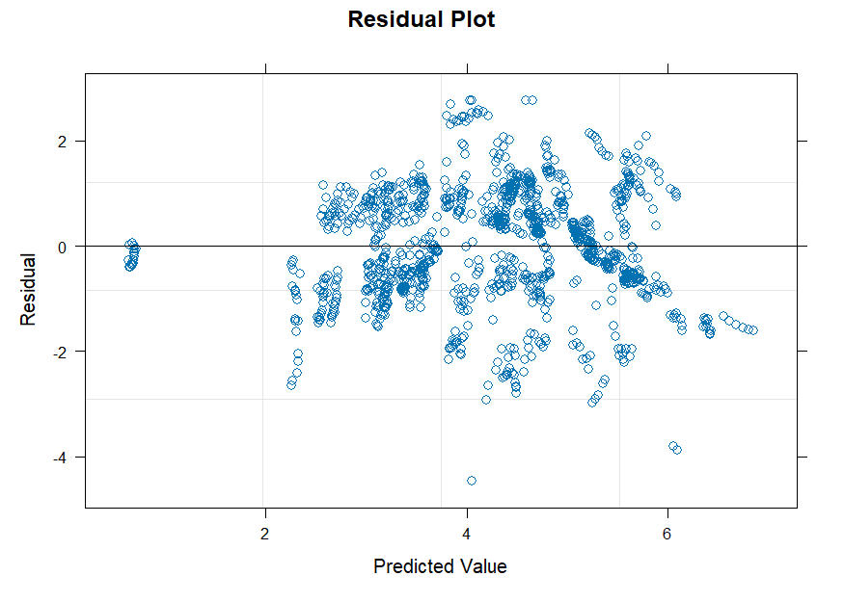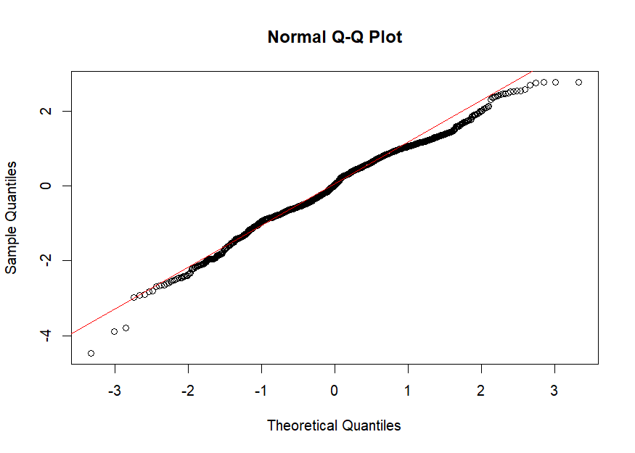
CH
The residual plot is not ideal but also does not raise any obvious red flags like coning that would indicate heteroskedasticity. However, there are a cluster of points with very small residuals near the origin. These points all belong to Switzerland, which likely has small residuals since it only reported rail emissions. There are also three points with residuals of a magnitude greater than 4 while the rest of the data scatters about 0 from -2 to 2. Additionally, the residuals also appear Normally distributed based upon the residuals largely aligning with the $y=x$ line in the Normal Q-Q plot.
Finally, we extrapolated our model to the US. For rail emissions, we computed 80% prediction intervals and consider only the fixed effects; i.e. we assume each US state is an average EU country, a simplifying assumption. Not surprisingly, these intervals are quite wide and are not the most informative. For example, in Texas the interval is (7.44, 122.46) with a point estimate of 28.27 g CO₂/PKM. The interval is not centered around the estimate due to having to back-transform from the log scale. The point estimates for air (101.54) and (224.25), though are greater than rail. Extrapolations for other states are in Appendix A.3. Overall, our model predicts that rail transit is more efficient than both air and road transit, so as far as emissions are concerned, rail transit merits attention as an alternative transit mode in the US.

- Safety
4.1 Exploratory Data Analysis
In order to explore safety, we looked at road and rail transport fatalities in accidents across multiple European countries across multiple years. We have 223 datapoints which consist of the Country, Year, Passenger Volume (millions of passenger-kilometers) for Rail and Road, and Fatalities in Rail and Road accidents. From this we can get fatalities by volume (# fatalities / passenger-kilometers for each of road/rail)
Fig. 4.1: Road/Rail Accidents by Volume across the years
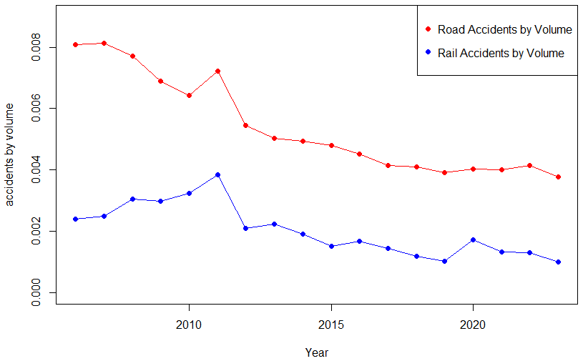
Figure 4.1 illustrates the change in road and rail accidents over the years. Rail accidents are consistently lower throughout the years, but there are some notable factors. First is a peak in fatalities for both in 2011. This is due to a higher number of countries reporting for this year. In 2020 there was a bump in rail accidents by volume that does not exist in road accidents. We believe this is because covid shut down the most active railways, which are often the safest. In addition, less people left their house due to the increase of things like remote work causing the roads to be emptier and thus safer.
For analysis we will be looking at the ratio of road accidents to rail accidents instead of the absolute difference. This is more intuitive because we can interpret it as there being, for instance, 1.5 road fatality for every 1 rail fatality.
Fig. 4.2: Countries with the highest and lowest ratio
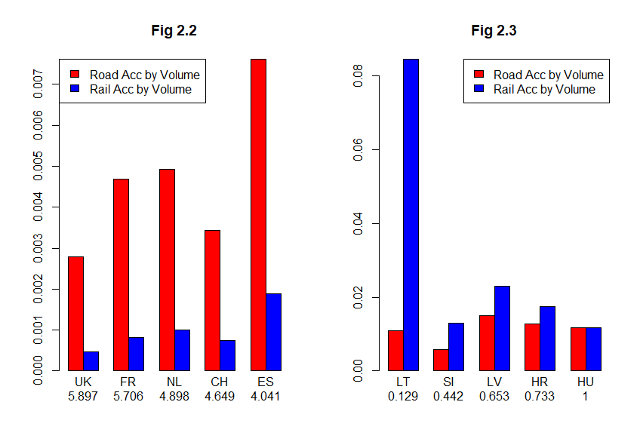
Looking at figure 4.2 we can see that the countries that have the highest relative safety are the most populous and the richest. This makes sense as countries with bigger populations have more transport demands causing public transport by rail to be more important. In addition, since they are richer, they can allocate more resources to such infrastructure.
In future modeling, we included 2 other factors that needed EDA. We looked at nominal GDP per capita over the years (B.1) and CRI score (B.2). CRI score is the tendency for a country to experience extreme weather affects like storms. The standouts in GDP were Switzerland, Norway and Denmark as having the highest per capita and Slovenia, Croatia and Latvia as being the poorest. CRI score had mountainous countries with colder climates like Finland, Sweden and Hungary.
4.2 Year by year analysis
4.2.1 Yearly Hypothesis Testing
For hypothesis testing we looked at the did a 1 tailed t-test for the ratio with H₀: μ = 1 and H_{a}: μ > 1 for each year. This tests whether roads are more dangerous than rail because if they are the same then the ratio is 1, and since the ratio is Road / Rail, greater than 1 means rail is safer.
Fig. 4.3: Ratio by year with 2-sided 95% CIs for each year
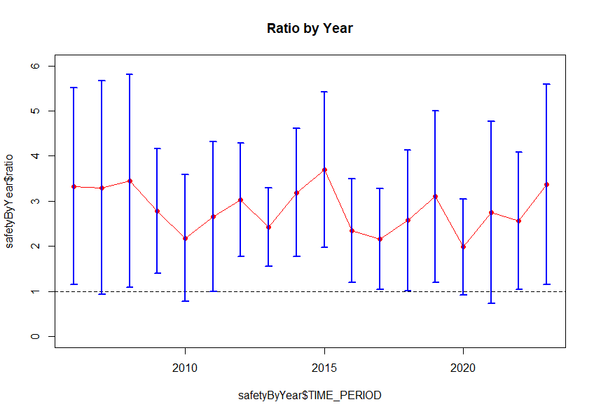
This graph shows the ratio of Road/Rail accidents by volume every year as an aggregate across countries. The blue lines are 2-sided 95% CIs for each year based on the hypothesis testing. The dotted line is 1, where road and rail are the same safety. The hypothesis testing that accompanied this graph ended up having significant p values for every year. This means every year, road was more dangerous than rail.
However, looking at the CIs and aggregates we find some interesting trends. In 2009-10 there was a dip in the ratio. We believe this was residual effects from the great recession in 2008. This recession caused lower car sales and thus a lower volume of people on the roads. This made the roads relatively safer causing a decrease in the ratio. There was a rise in the ratio in 2014-15 which can be attributed to a large decrease in rail accidents by volume in Spain, France and the UK due to new rail infrastructure being implemented. In 2020, as mentioned earlier in the EDA sections, roads became relatively safer and was reflected in the aggregate ratio with a global minimum.
4.2.2 Yearly Linear Models
For each year we also fitted a linear model to predict the ratio based on three factors: GDP, CRI Score and Area. GDP was chosen because more money would mean more infrastructure spending. CRI score was chosen to evaluate whether weather affected rail or road more. Area was chosen as the physical distance to travel might cause roads to be more dangerous as there are more opportunities for accidents in an already more accident-prone mode of transportation.
Fig. 4.4: Linear Models for each year and their estimates
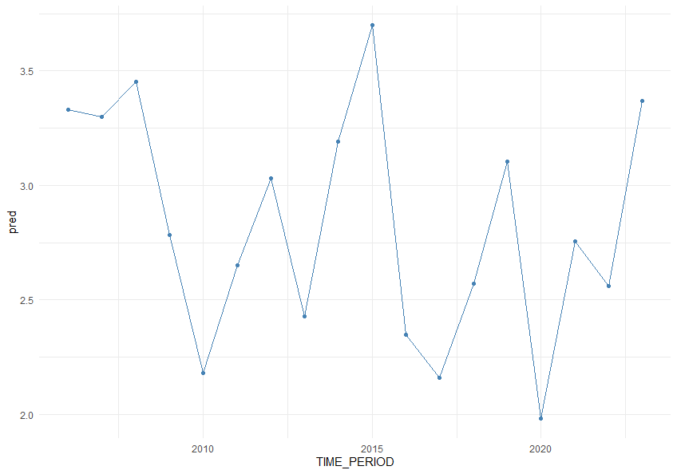
We modeled the ratio based on these factors for every year and then estimated what the “average” country (by average all of the predictors) in the EU would look like throughout the year based on these models. It managed to identify some of the points mentioned before like the dip in 2009-10, the dip in 2020 and the spike in 2014-15.
Only one year for these models had non-normal residuals. The UK in 2016 was an outlier in the residuals due to the beginning of a railway strike that shut down a significant amount of private railways. These must have caused the safety to get higher as people were funneled into national railways that were safer and caused the ratio to tank.
The CRI Score was only significant as a predictor in 1 out of the 18 years. We reason that this might be insignificant for two possible reasons. Firstly, it could just be that heavy weather conditions, even in those countries more prone to it, are not common enough to affect yearly statistics. Secondly, it could be that during storms, trains often cancel service and people generally cancel events so train statistics aren’t affected, and there are generally fewer road accidents these days because there are less people on the roads.
GDP was significant for 11 out of the 18 years. This estimate was positive and it makes sense as it shows that richer countries can spend more on newer, safer railways. This is backed up by our earlier note of the ratio being increased massively by the new infrastructure introduced in 2014-15.
Area was significant for 7 out of the 18 years. This estimate was also positive, and we think there are two reasons for this. One could be the longer roads mentioned earlier that lead to longer road trips and more accidents. The other reason could be that larger countries end up creating more and bigger urban centers. This causes there to be more intra-city roads that have high traffic and cause the most accidents.

4.3 Mixed Effects
Our final model was a mixed effects model with log(area) and log(gdp) as fixed effects and geo (country) as the random effect.
${ratio}_{ij}=β_{0}+β_{1}{log⁡(area)}_{ij}+β_{2}{\text{gdp}}_{ij}+{geo}_{j}+ϵ_{ij}$
Where i is the year index and j is the country. The results of the analysis are in the following two tables.
Fig. 4.5: Fixed Effects Table
Source | Est | SE | DF | T | p
(int) | -22.03 | 5.62 | 19.31 | -3.9 | 0.0009
log(Area) | 0.63 | 0.3 | 14.05 | 2.08 | 0.056
log(gdp) | 1.69 | 0.46 | 25.96 | 3.64 | 0.001
The fixed effects match closely with our previous results from yearly analysis. CRI score was removed as it was never significant across all tested models. GDP was quite significant with a positive estimate, and area was only significant at only the 90% confidence level but also had a positive estimate.

Fig. 4.6: Random Effects Table
Groups | Var | sd | % Var
geo | 1.741 | 1.319 | 83.67%
resid | 2.067 | 1.4389 | 100%
As we can see, the country accounts for a majority of the variance between countries. This accounts for intangible aspects of transport culture between countries such as Lithuania which had a vast highway network as one of its first infrastructure projects which it then expanded instead of building more rail. It also accounts for things like price of transport which could not be used in this analysis because a lot of rail is private and thus doesn’t have readily available price data.
B.3 has the residuals for this model. There is a clear cone pattern with a higher variance with higher fitted values. This makes sense, as a higher ratio means higher area and gdp. A higher gdp means more wealth classes that may have different cultures, as rich people might be more likely to drive and don’t need public transport rails. A higher area also means that its harder to implement railway systems so they may be less common and less sophisticated leading to a different level of safety.
4.4 Extrapolation
To try to extrapolate these results to the US we looked at the marginal estimate for these results as well as conditional estimates. For conditional estimates we tried to match some states to countries in our dataset with corresponding GDPs to show that we have the monetary capability to build such rail systems.
Fig. 4.7: Safety Extrapolation
State | EU | Marg. CI | Cond. CI
TX | NO | (2.330,8.58) | (3.75,10.12)
CA | CH | (2.40,8.58) | (3.65,9.99)
CO | NO | (2.24,8.3) | (3.36,9.72)
MN | UK | (1.79,7.92) | (3.63,10.04)
NY | CH | (1.86,8.14) | (3.45,9.59)
As we can see from our extrapolation, these states are rich enough to be compared to the richest countries in Europe and have the means to create not only safe rail systems, but ones much safer than those in the average countries of Europe. The US could save many lives through building rail transport while we already have the means to do so. One thing of note, however, is that there is a much larger car culture in the US, meaning the random effect might be much higher in the US because there isn’t a country in Europe with the same sort of resistance to public transport.

- Travel Time
5.1 Exploratory Data Analysis
The dataset for travel time contained the travel time in hours for rail and flight transport across specific city corridors in Europe. In addition, it had the distance of the trip (in km) and whether a railway was “High-Speed” or not. This was determined by whether the average speed of the railways was higher or lower than 200km. One note is that the travel time included all factors for passengers including things like wait time and going through security. We had 297 datapoints, 14 of which were High Speed Rail (HSR).
Fig. 5.1: Flight vs. Rail Duration
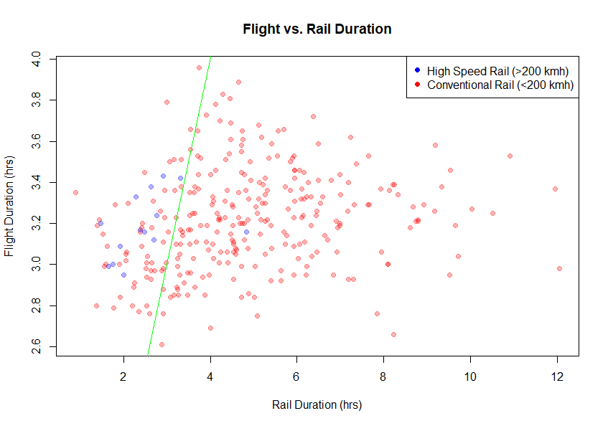
Figure 5.1 illustrates the duration of the trip in hours for rail transport versus flight transport. The blue points are the points classified as HSR. The green line is y=x, meaning the trip took the same amount of time for both modes of transportation. Most of the points lie on the right side of this line, showing that rail is generally slower than flights. However, when looking at the HSR points we see most of them are to the left of the green line meaning they are faster than flights.
Fig. 5.2: Distance (km) vs. Time Ratio (Rail/Flight) (hr)
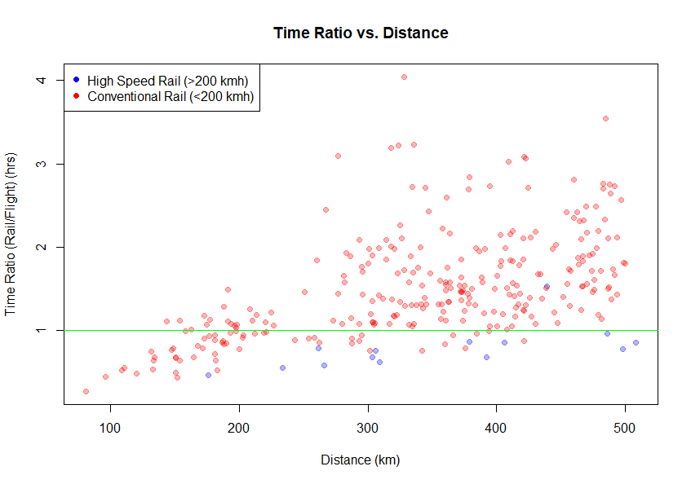
Figure 5.2 looks at the relationship between the efficiency of rail travel compared to distance. This is done by putting the ratio of rail travel to flight travel on the vertical axis and putting the distance on the horizontal axis. The green line here represents the same thing as in the previous figure, it is y=1 meaning the ratio of rail to flight is the same (meaning the trip took the same amount of time). As we can see, there’s a higher concentration of points below the line for smaller distances. This suggests that rail is relatively more effective as a mode of transport on lower-distance trips. This is in line with previous research of the subject which suggests there’s a “Goldilocks” zone of rail transport between 100-500km where rail is particularly effective.

5.2 Hypothesis Testing
The first analysis done was a paired t-test as described in section 2.1. We took a two-sided t-test for both conventional and high-speed rail to see if the difference between rail and flight hours was 0 (which would mean rail and flight travel times were the same).
Fig. 5.3: Paired t-test results
 | Conventional | High-speed
T | 14.279 | -3.1829
P | <2.2e-16 | 0.0072
diff | 1.689 | -0.670
95% CI | (1.456,1.922) | (-1.139,-0.217)
As we can see in Fig 5.3, we got significant results showing a difference in travel time across both tests. Notable, the difference is positive for conventional and negative for high-speed. Since we’re looking at the difference Rail – Flight time, this suggest conventional rail is slower while HSR is faster than flights. The 95% CIs support this, as neither contain 0 (indicating no difference) but CR has its CI completely positive and HSR has its CI completely negative.
5.3 Modeling
We ended up fitting a simple linear model of the ratio of rail to flight time to the log of distance for a trip. The resulting models were the following for conventional rail and high-speed rail respectively:
$${ratio}_{i}=-2.1934+0.511{\log{(Dist)}}_{i}$$
$${ratio}_{i}=-4.0573+0.9668{\log{(Dist)}}_{i}$$
Notably, the coefficient estimate for both distance predictors were positive. This supports the idea that flights are more suitable for longer trips while trains end up being more efficient for shorter ones. However, for HSR, while more efficient for shorter distances, the relationship is significantly smalling indicating it can be used for longer distances. To be specific, for the ratio estimate to be 1 or greater the distance must be 512.66 km greater. This is around the upper bound of mid-range trips that previous research has shown rail is particularly effective for.
Appendix C.1 contains the residual plot for the conventional rail model which shows a clear cone pattern. This model seems to have clear heteroskedasticity issues. The variance increasing based on distance makes sense specifically due to how flights work. As the distance increases there is a greater chance of delay or turbulence and the importance of small optimizations in flight paths matter more. As a result, longer flights have a large opportunity to save or lose time that a shorter flight doesn’t. This leads to greater variance in flight times and thus the ratio as distance increases. The Shapiro test’s p values of 1.41$e$-11 and 0.00083 for CR and HSR support that these are non-normal residuals.
Unfortunately, due to the low number of predictive features in this dataset and few descriptors means there isn’t an opportunity to maybe add more predictors or try to account for these parts of the model.

5.4 Extrapolation
In order to extrapolate hypothetical effects in the US, we took some of the most common midrange flights between domestic airports.
Fig. 5.4: Linear Model Extrapolation
Route | Dist | fLT | cr 95% CI | hsr 95% CI
dal-sat | 397 | 1.167 | (1.66,1.80) | (0.73,0.99)
lax-sfo | 543.1 | 1.5 | (1.93,2.13) | (0.80,1.25)
den-cos | 117.3 | 0.833 | (0.38,0.72) | (-0.19,0.68)
jfk-bos | 300.5 | 1.333 | (1.40,1.52) | (0.59,0.85)
These extrapolation results follow generally what we expected, with CR mostly having CIs above 1 (meaning slower than flights) and HSR having CIs below 1 (meaning faster than flights). There were two notable results. LAX-SFO is the most traveled domestic flight in the US, and is the only trip which HSR contains 1. This means that it’s not definitely faster than flights for this trip, and this makes sense as it is the longest flight here at 543 km. This supports that rail should be limited to mid-range trips that are more appropriate. The other notable prediction was CR having a CI completely below 1 for DEN-COS. Denver to Colorado Springs is one of the most common transfer flights in the country due to Denver being a big hub, but Colorado Springs giving access to smaller parts of the state. What this CI tells us is that for smaller transfer flights like this one, conventional is a viable and maybe even faster option. This could be applied throughout the US, with one perhaps being between us in College Station and big hub cities in Texas like Austin or Houston.
- Conclusions and Comments
In this paper, we have quantified and modeled what proponents of rail transit often argue: rail is more emissions efficient, safer, and in particular contexts, even faster than road and air travel. That said, we do note that our dataset is limited, and as mentioned, our models do not capture all of the variability that we see in each of these aspects. Further, our extrapolations ought to be considered cautiously. Our extrapolations do point in the same general direction, though, and that is that if implemented, rail provides quite the competitive alternative. Rail will almost certainly continue to face political and regulatory challenges, but our analysis demonstrates that this should not be due to its merits.

References
“Air Carriers : T-100 Domestic Segment (U.S. Carriers).” TranStats, Bureau of Transportation Statistics, June 2025, www.transtats.bts.gov/DL_SelectFields.aspx?gnoyr_VQ=FIM&QO_fu146_anzr=Nv4%2 0Pn44vr45.
“Breakeven Distances between Conventional Rail, High Speed Rail and Air Transportation.” The Spatial Organization of Transportation and Mobility, The Geography of Transport Systems, 18 Apr. 2024, transportgeography.org/contents/applications/high-speed-rail-systems/breakeven-distances-rail-air-transport/.
Bureau of Transportation Statistics. United States Department of Transportation, bts.gov.
European Environment Agency. “Air quality statistics.” European Environment Agency, 31 Oct. 2025, eea.europa.eu/en/analysis/maps-and-charts/air-quality-statistics-dashboards?activeTab=570bee2d-1316-48cf-adde-4b640f92119b.
Eurostat. “Air emissions accounts by NACE Rev. 2 activity (env_ac_ainah_r2).” Eurostat, ec.europa.eu/eurostat/databrowser/view/env_ac_ainah_r2__custom_18136650/default/table.
Eurostat. “Database – Transport.” Eurostat, ec.europa.eu/eurostat/web/transport/database.
Eurostat. “Railway transport.” Eurostat, ec.europa.eu/eurostat/web/transport/information-data/railway-transport.
Lindenmaier, László, et al. “Real-time rail energy consumption minimization: Optimal speed profile planning.” 2024 IEEE 18th International Symposium on Applied Computational Intelligence and Informatics (SACI), 23 May 2024, pp. 000175–000182, https://doi.org/10.1109/saci60582.2024.10619839.
U.S. Census Bureau. “Annual Estimates of the Resident Population for the United States, Regions, States, District of Columbia, and Puerto Rico: April 1, 2020 to July 1, 2024 (NST-EST2024-POP).” State Population Totals: 2020-2024, www2.census.gov/programs-surveys/popest/tables/2020-2024/state/totals/NST-EST2024-POP.xlsx.
World Bank. “Land area (sq. km) (AG.LND.TOTL.K2).” World Development Indicators, databank.worldbank.org/reports.aspx?source=2&series=AG.LND.TOTL.K2&country=EUU.

Appendix
Appendix A
A.1: Rail PKM over Time, select countries
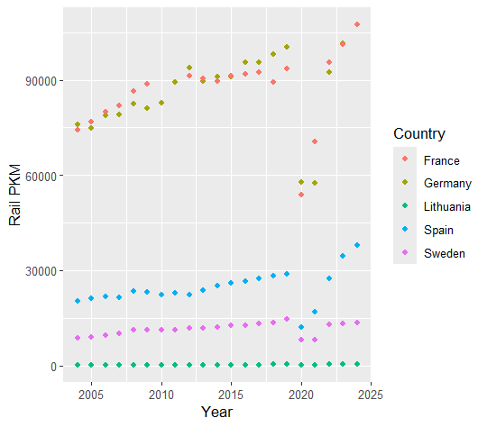

A.2: Correlation of mixed effects for emissions mixed model
Correlation of Fixed Effects:
(Intr) MdArTr MdRdTr
MdArTrnsprt -0.213
MdRdTrnsprt -0.176 0.397
gdp_c -0.026 -0.080 0.133

A.3: Extrapolations to other US states of emissions model
California
- Rail
Estimate: 26.69, Interval: (6.72, 111.01)
- Air
Estimate: 89.59
- Road
Estimate: 215.29
Colorado
- Rail
Estimate: 27.16, Interval: (6.63, 110.93)
- Air
Estimate: 98.10
- Road
Estimate: 226.38
Minnesota
- Rail
Estimate: 29.75, Interval: (7.27, 112.67)
- Air
Estimate: 106.51
- Road
Estimate: 216.98
New York
- Rail
Estimate: 24.54, Interval: (6.15, 99.61)
- Air
Estimate: 91.27
- Road
Estimate: 197.50

Appendix B
B.1: GDP per capita over time
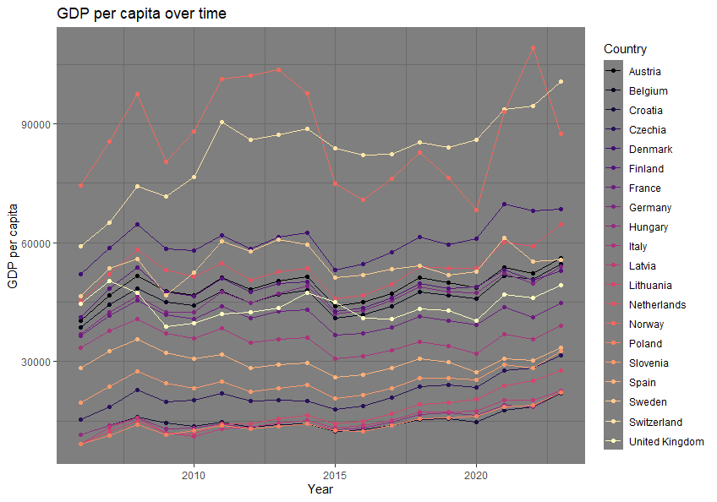
B.2: CRI score by country
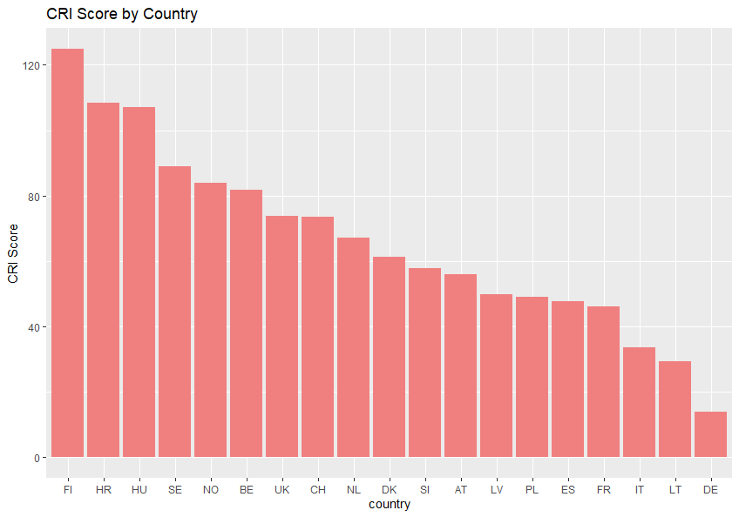
B.3: Safety score residuals
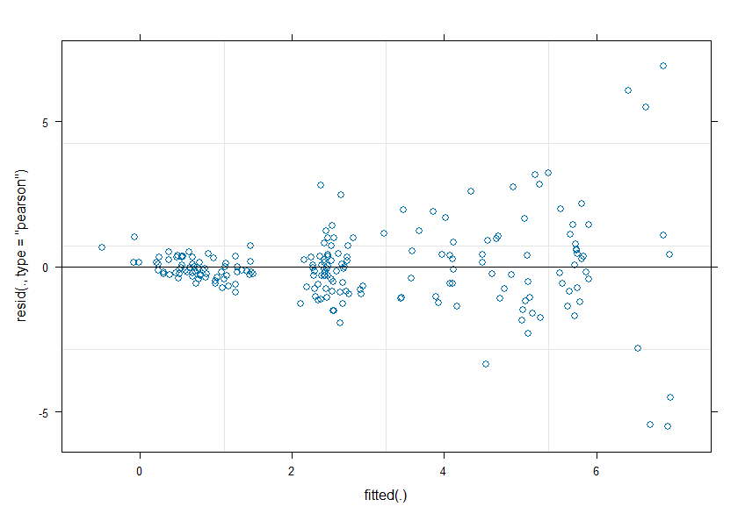
Appendix C
C.1: Travel Time CR Residuals vs Fitted
